September 2021

Cayton School | Medium Term Curriculum Plan Year 4 – Spring 1

Learn from yesterday, seek today and aimfor tomorrow

GeographyDriver: Rivers / Mountains

Key Enquiry: Why are most of the world’s cities located by rivers?

Geography Driver

What I need the children to learn |  | Possible learning experiences
Human and Physical Geography
describe and understand key aspects of physical geography, including: climate zones, biomes and vegetation belts, rivers, mountains, volcanoes and earthquakes, and the water cycle | describe and understand key aspects of human geography, including types of settlement and land use, economic activity including trade links, and the distribution of natural resources including energy, food, minerals and water
- Know and label the main features of a river  - Know the name of and locate a number of the world’s longest rivers  - Know the names of a number of the world’s highest mountains  - Explain the features of a water cycle | - Know why most cities are located by a river | World map locating major rivers and mountain peaks  Label main parts of a river. Discuss how rivers change over time and how you can tell whether a river is old or new.  Labelling water cycle with explanations  Make a mini water cycle in a bag  Vineyards on mountains in Italy  Rice Fields in China  Research trade links between countries  Famine crisis in Africa  Make your own river with settlements at the side  Ancient Egypt – irrigation systems
Locational Knowledge
name and locate counties and cities of the United Kingdom, geographical regions and their identifying human and physical characteristics, key topographical features (including hills, mountains, coasts and rivers), and land-use patterns; and understand how some of these aspects have changed over time | identify the position and significance of latitude, longitude, Equator, Northern Hemisphere, Southern Hemisphere, the Tropics of Cancer and Capricorn, Arctic and Antarctic Circle, the Prime/Greenwich Meridian and time zones (including day and night)
- Know where the main mountain regions are in the UK  - Know, name and locate the main rivers in the UK | - Know where the equator, Tropic of Cancer, Tropic of Capricorn and the Greenwich Meridian are on a world map  - Know what is meant by the term ‘tropics’ | Time zones  Globe investigation linked to map  Link to season work previously completed  Own county – Study of the North Yorkshire Moors – possible Visit  Historical photographical evidence of Scarborough through the years  Labelling maps  Google Earth investigations  6 main river locations

Geography

What I need the children to learn | Possible learning experiences
Geographical skills and fieldwork
use maps, atlases, globes and digital/computer mapping to locate countries and describe features studied
- Use maps and globes to locate the equator, the Tropics of Cancer and Capricorn and the Greenwich Meridian | Google Earth study to locate countries  Time zones study linked to night/ day  Spring Equinox

Science

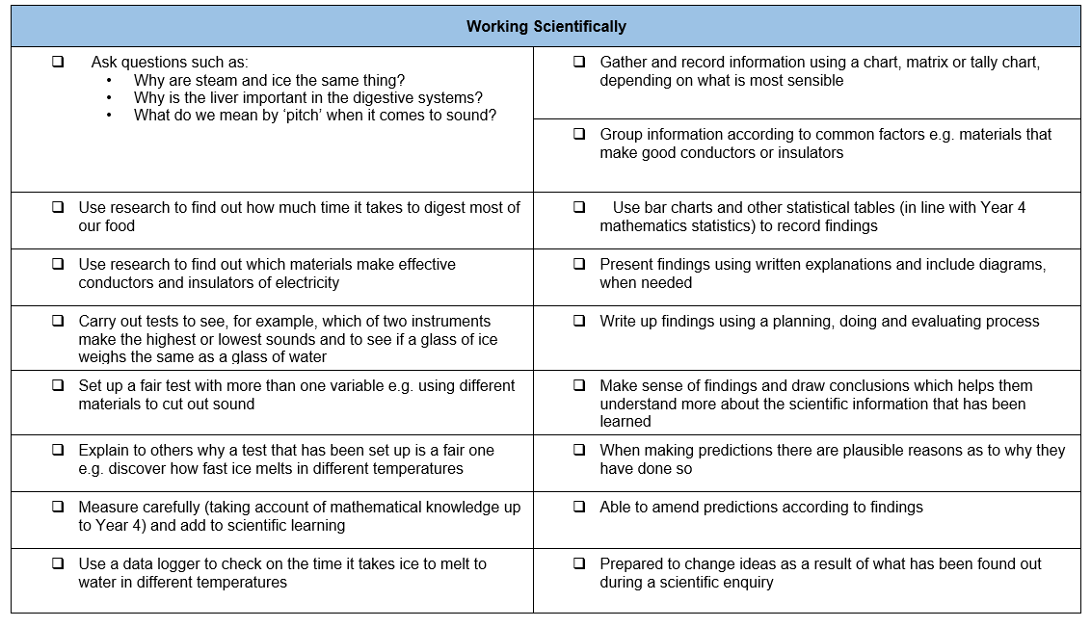

What I need the children to learn | Possible learning experiences
States of Matter
Compare and group materials
Solids, liquids and gases
Changing state
Water cycle
- Know the temperature at which materials change state  - Know about and explore how some materials can change state  - Know the part played by evaporation and condensation in the water cycleand to connect the rate of evaporation with temperature  - Group materials based on their state of matter (solid, liquid, gas) | Directly proportional straight-line graphs in Mathematics  How to get an ice cube to melt in the quickest way  Let children experiment with different materials, sunny position etc  Address misconception that wrapping the ice cube will not heat it up and melt it but will actually insulate the cold  Water cycle in a bag – evaporation experiment with sandwich bags stuck on the window – measure  Diagrams of cycle from solid to liquid gas and vocabulary – melting, evaporating, condensation, solidifying, mention sublimation

Computing

What I need the children to learn | Possible learning experiences
Search engines
Pupils should be taught to use search technologies effectively, appreciate how results are selected and ranked, and be discerning in evaluating digital content
- select and use software to accomplish given goals | No iCompute Unit

Music

What I need the children to learn | Possible learning experiences
Appreciate
appreciate and understand a wide range of high-quality live and recorded music drawn from different traditions and from great composers and musicians | St.Saens - listening to and appreciating “Aquarium” from “Carnival of the Animals. Link with theme of water.
- play and perform in solo and ensemble contexts, using their voices and playing musical instruments with increasing accuracy, fluency, control and expression | Create own water music, using percussion instruments to represent water sounds. Possible use of glass jars to make a range of “notes”.

Art

What I need the children to learn | Possible learning experiences
Using Sketchbooks
create sketch books to record their observations and use them to review and revisit ideas
- know how to integrate digital images into artwork.  - Use sketchbooks to help create facial expressions  - use sketchbooks to experiment with different texture  - use photographs to help create reflections | Sketch rivers and landscapes  Make riverscapes using collage materials and experiment with different colours and tones.

Physical Education – Follow Real P.E. and supplement with NC P.E. experiences

What I need the children to learn | Possible learning experiences
Athletics
use running, jumping, throwing and catching in isolation and in combination
- sprint over a short distance and show stamina when running over a long distance  - jump in different ways  - throw in different ways and hit a target, when needed | Build on previous years basic skills, adding them to competition games, personal targets  Links to Real PE 3
Competitive Games
play competitive games, modified where appropriate [for example, badminton, basketball, cricket, football, hockey, netball, rounders and tennis], and apply basic principles suitable for attacking and defending
- throw and catch accurately with one hand
- hit a ball accurately with control
- vary tactics and adapt skills depending on what is happening in a game
Gymnastics
develop flexibility, strength, technique, control and balance [for example, through athletics and gymnastics]
- move in a controlled way
- include change of speed and direction in a sequence
- work with a partner to create, repeat and improve a sequence with at least three phases
Dance
perform dances using a range of movement patterns | Make sequences to represent the course of a river.
- take the lead when working with a partner or group
- use dance to communicate an idea
Outdoor and Adventurous Activity
take part in outdoor and adventurous activity challenges both individually and within a team
- follow a map in a (more demanding) familiar context
- follow a route within a time limit
Evaluate
compare their performances with previous ones and demonstrate improvement to achieve their personal best
- provide support and advice to others in gymnastics and dance  - be prepared to listen to the ideas of others | Give critical feedback with in direct response to key questions/challenges.
Real P.E.
Unit 3 Cognitive
- I can understand the simple tactics of attacking and defending. I can explain what I am doing well and I have begun to identify areas for improvement.
Nigel Carson Sessions
PSHE

What I need the children to learn | Possible learning experiences
Dreams & Goals | Resource links from: Jigsaw
• Know what their own hopes and dreams are  • Know that hopes and dreams don’t always  come true  • Know that reflecting on positive and happy  experiences can help them to counteract  disappointment  • Know how to make a new plan and set new  goals even if they have been disappointed  • Know how to work out the steps they need to  take to achieve a goal  • Know how to work as part of a successful  group  • Know how to share in the success of a group. | In this Puzzle the children talk about their hopes and dreams. They discuss how it feels when dreams don’t come true and how to cope with / overcome  feelings of disappointment. The children talk about making new plans and setting new goals even if they have been disappointed. The class talk about  group work and overcoming challenges together. They reflect on their successes and the feelings associated with overcoming a challenge.  See the link below

https://jigsawlivestcmsuk.blob.core.windows.net/umbraco-media/j0jfera1/05-ages-8-9-jigsaw-skills-and-knowledge-progression-for-parents.pdf

Religious Education

What I need the children to learn | Possible learning experiences
L2.9
- What can we learn from religions about deciding what is right or wrong? | Investigate the ten commandments and how Christians believe these show us how to live our lives.  Investigating and making comparisons with some other religions - which teachings help them to live their lives in a particular way?

Foreign Languages

What I need the children to learn | Possible learning experiences
Speaking
speak in sentences, using familiar vocabulary, phrases and basic language structures
- name and describe people, a place and an object
- have a short conversation, saying 3 to 4 things
- give response using a short phrase
- start to speak, using a full sentence
Reading
develop accurate pronunciation and intonation so that others understand when they are reading aloud or using familiar words and phrases
- read and understand a short passage using familiar language
- explain the main points in a short passage
- read a passage independently
- use a bilingual dictionary or glossary to look up new words
Writing
broaden their vocabulary and develop their ability to understand new words that are introduced into familiar written material, including through using a dictionary
- write phrases from memory
- write 2-3 short sentences on a familiar topic
- write what they like/dislike about a familiar topic

Cayton Creation

Use a watering can down the School drive to show how water will flow where it wants to. Notice debris collected and deposited.

Cayton Conclusion

Make a mud river bed to include a meander and possible ox-bow, from their prior knowledge.

English

What I need the children to learn | Possible learning experiences
Can I write a range of narratives and non-fiction pieces using a consistent and appropriate structure (including genre-specific layout devices)? | Information text writing about rivers and the water cycle. Use of diagrams.
Can I write a range of narratives that are well- structured and well-paced.?
Can I compose and rehearse sentences orally (including dialogue), progressively building a varied and rich vocabulary and an increasing range of sentence structures? | Preparing for writing.
Can I consistently organise my writing into paragraphs around a theme to add cohesion and to aid the reader?
Can I create detailed settings, characters and plot in narratives to engage the reader and to add atmosphere? | Using Literacy Shed for short film clips to help with settings.
Can I begin to read aloud my own writing, to a group or the whole class, using appropriate intonation and to control the tone and volume so that the meaning is clear?
Can I proofread consistently and amend my own and others’ writing, correcting errors in grammar, punctuation and spelling and adding nouns/ pronouns for cohesion? | Response time and discussion about other’s work.
Can I always maintain an accurate tense throughout a piece of writing?
Can I always use Standard English verb inflections accurately, e.g. ‘we were’ rather than ‘we was’ and ‘I did’ rather than ‘I done’? | Specific stand-alone lessons to achieve this, both oral and written.
Can I use subordinate clauses, extending the range of sentences with more than one clause by using a wider range of conjunctions, which are sometimes in varied positions within sentences? | Sentence construction towards the start of the term.  Consolidate
Can I expand noun phrases with the addition of ambitious modifying adjectives and prepositional phrases, e.g. the heroic soldier with an unbreakable spirit? | Sentence construction towards the start of the term.  Consolidate
Can I consistently choose nouns or pronouns appropriately to aid cohesion and avoid repetition, e.g. he, she, they, it? | Specific lessons and Response Time.
Can I use all of the necessary punctuation in direct speech, including a comma after the reporting clause and all end punctuation within the inverted commas? | Sentence construction towards the start of the term.
Can I consistently use apostrophes for singular and plural possession? | Specific lessons and Response Time.  See **
Can I recognise and use the terms determiner, pronoun, possessive pronoun and adverbial? | Specific lessons and Response Time.
Can I spell words with / shuhn/ endings spelt with ‘sion’ (if the root word ends in ‘se’, ‘de’ or ‘d’, e.g. division, invasion, confusion, decision, collision, television)? | Y4 spelling unit.
Can I spell words with a / shuhn/ sound spelt with ‘ssion’ (if the root word ends in ‘ss’ or ‘mit’, e.g. expression, discussion, confession, permission, admission)? | Y4 spelling unit.
Can I spell words with a / shuhn/ sound spelt with ‘tion’ (if the root word ends in ‘te’ or ‘t’ or has no definite root, e.g.  invention, injection, action, hesitation, completion)? | Y4 spelling unit.
Can I spell words with a / shuhn/ sound spelt with ‘cian’ (if the root word ends in ‘c’ or ‘cs’? e.g. musician, electrician, magician, politician, mathematician)? | Y4 spelling unit.
Can I spell words with the s/ sound spelt with ‘sc’ (e.g. sound spelt with ‘sc’  (e.g. science, scene, discipline, fascinate, crescent)? | Y4 spelling unit.
Can I correctly spell most words with the prefixes in-, il-, im-, ir-, sub-, super-, anti-, auto-, inter-, ex- and non- (e.g. incorrect, illegal, impossible, irrelevant, substandard, superhero, autograph, antisocial, intercity, exchange, nonsense)? | Y4 spelling unit.
Can I form nouns with the suffix -ation (e.g. information, adoration, sensation, preparation, admiration)? | Y4 spelling unit.
Can I spell words with the suffix -ous with no change to root words, no definitive root word, words ending in ‘y’, ‘our’ or ‘e’ and the exceptions to the rule (e.g. joyous, fabulous, mysterious, rigorous, famous, advantageous)? | Y4 spelling unit.
Can I spell words that use the possessive apostrophe with plural words, including irregular plurals (e.g. girls’, boys’, babies’, children’s, men’s, mice’s)? | As for **
Can I use my spelling knowledge to use a dictionary more efficiently? | Introduce using a dictionary and if ready, use letters to the second and third place.
Can I spell all of the Y3 and Y4 statutory spelling words correctly? | Baseline assessment at the start of term. Half-termly assessment to check on progress.
Can I increase the legibility, consistency and quality of my handwriting [e.g by ensuring that the downstrokes of letters are parallel and equidistant; that lines of writing are spaced sufficiently so that the ascenders and descenders of letters do not touch? | Handwriting sessions.
Can I confidently use diagonal and horizontal joining strokes throughout my independent writing to increase fluency? | Handwriting sessions.
Can I read most words fluently and attempt to decode any unfamiliar words with increasing speed and skill? | Guided Reading will have to take the form of whole class work until further notice.  Any “gaps” shown through Y3 Summer Term assessment done at the start of Y4 Autumn term, to be addressed.
Can I apply my knowledge of root words, prefixes and suffixes/word endings to read aloud fluently.*? | Guided/whole class reading.

Mathematics

What I need the children to learn | Possible learning experiences
Number: Multiplication and division (3 weeks)
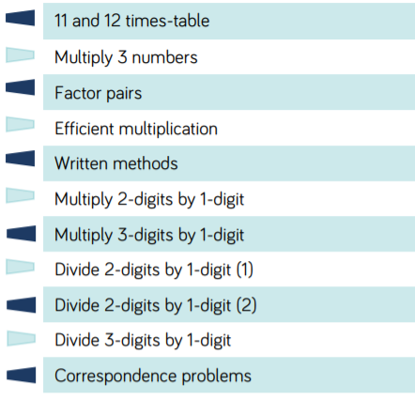 | Homework
 | White Rose Maths Hub
 | White Rose and NRich problem-solving
 | White Rose and NRich problem-solving
Measurement: Area (1 week)
Number: Fractions (4 weeks) Continue into new term to make up the weeks.
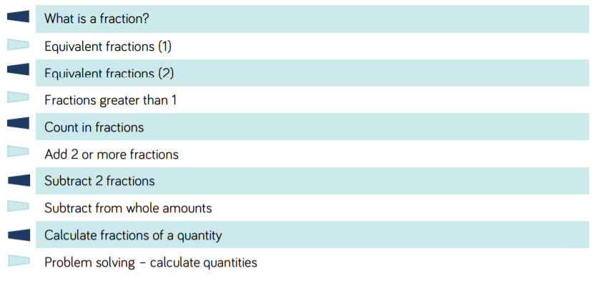
 | White Rose and NRich problem-solving

