September 2021

Cayton School | Medium Term Curriculum Plan Year 3 - Autumn 1

Learn from yesterday, seek today and aimfor tomorrow

Geography Driver: Natural Disasters

Key Enquiry: What makes the earth angry?

Geography Driver

What I need the children to learn |  | Possible learning experiences
Human and Physical Geography
describe and understand key aspects of physical geography, including: climate zones, biomes and vegetation belts, rivers, mountains, volcanoes and earthquakes, and the water cycle | describe and understand key aspects of physical geography, including: climate zones, biomes and vegetation belts, rivers, mountains, volcanoes and earthquakes, and the water cycle
- Know what causes an earthquake  - Label the different parts of a volcano |  | Puddle evaporation link to diagram of water cycle  Study of climate zones to different biomes  Make your own river experiment  Volcano building – links to chemical changes – science  Identifying plates and fault lines around the world

Geography

What I need the children to learn | Possible learning experiences
Locational Knowledge
name and locate counties and cities of the United Kingdom, geographical regions and their identifying human and physical characteristics, key topographical features (including hills, mountains, coasts and rivers), and land-use patterns; and understand how some of these aspects have changed over time
- Know the names of and locate at least eight counties and at least six cities in England | Large UK map study  Sorting activity for changing landscape: physical or human  Past/ present photographs of landscapes  Choose 6 main cities to label and identify on a map

Science

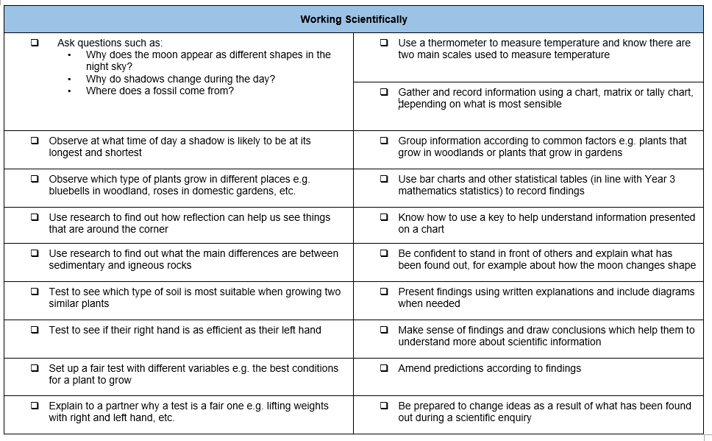

What I need the children to learn | Possible learning experiences
Forces
Different Forces
Magnets
- Know about and describe how objects move on different surfaces  - Know how a simple pulley works and use to on to lift an object  - Know how some forces require contact and some do not, giving examples  - Know about and explain how magnets attractonly Iron, Nickel, Cobalt and stainless steel (alloy) not all metals and repel Predict whether magnets will attract or repel and give a reason | Use the hall  Test different carpet surfaces on a ramp – smooth and rough  Talk about gravity, air resistance, up thrust, magnets, friction  Make a simple pulley  Mining from the Earth: Use magnets to mine different metals from a table (or other area) – only iron, nickel, steel, cobalt are magnetic – left on the table would be copper, aluminium, foil, gold, silver  Car travelling experiment, gravity (falling test speed)upthrust paper aeroplanes

Computing

What I need the children to learn | Possible learning experiences
Safe use
Pupils should be taught to use technology safely, respectfully and responsibly; recognise acceptable/unacceptable behaviour; identify a range of ways to report concerns about content and contact
- use technology respectfully and responsibly  - Know different ways they can get help if concerned | https://www.icompute-uk.com/members-area/lks2/index.html and select the Year 3 folder and then the iSafe unit.

Design Technology

What I need the children to learn | Possible learning experiences
Designing
use research and develop design criteria to inform the design of innovative, functional, appealing products that are fit for purpose, aimed at particular individuals or groups

generate, develop, model and communicate their ideas through discussion, annotated sketches, cross-sectional and exploded diagrams, prototypes, pattern pieces and computer-aided design

- prove that a design meets a set criteria  - design a product and make sure that it looks attractivechoose a material for both its suitability and its appearance | Design and make own volcano experiment  Paper Mache/ water bottle
Making
select from and use a wider range of tools and equipment to perform practical tasks [for example, cutting, shaping, joining and finishing], accurately

select from and use a wide range of materials and components, including construction materials, textiles and ingredients, according to their functional properties and aesthetic qualities
- follow a step-by-step plan, choosing the right equipment and materials  - select the most appropriate tools and techniques for a given task  - make a product which uses both electrical and mechanical components  - work accurately to measure, make cuts and make holes | Prep experiment using vinegar and bicarbonate of soda
Evaluating
investigate and analyse a range of existing products

evaluate their ideas and products against their own design criteria and consider the views of others to improve their work

understand how key events and individuals in design and technology have helped shape the world
- explain how to improve a finished model  - know why a model has, or has not, been successful | How well did the explosion work?  Use technical language

Physical Education – Follow Real P.E. and supplement with NC P.E. experiences

What I need the children to learn | Possible learning experiences
Athletics
use running, jumping, throwing and catching in isolation and in combination
- run at fast, medium and slow speeds; changing speed and direction
- take part in a relay, remembering when to run and what to do
Competitive Games
play competitive games, modified where appropriate [for example, badminton, basketball, cricket, football, hockey, netball, rounders and tennis], and apply basic principles suitable for attacking and defending
- be aware of space and use it to support team-mates and to cause problems for the opposition  - know and use rules fairly | Useful when evaluating skills learnt
Gymnastics | Autumn and free weeks after Real PE
develop flexibility, strength, technique, control and balance [for example, through athletics and gymnastics]
- adapt sequences to suit different types of apparatus and criteria  - explain how strength and suppleness affect performance | Floor routines x2 weeks – links to Real PE 1
Dance
perform dances using a range of movement patterns
- improvise freely and translate ideas from a stimulus into movement
- share and create phrases with a partner and small group
- remember and repeat dance perform phrases
Outdoor and Adventurous Activity
take part in outdoor and adventurous activity challenges both individually and within a team
- follow a map in a familiar context
- use clues to follow a route
- follow a route safely
Evaluate
compare their performances with previous ones and demonstrate improvement to achieve their personal best
- compare and contrast gymnastic sequences  - recognise own improvement in ball games | Linked to sports games – how did they use the skill in performances?
Swimming
- start to swim aiming for competency, confidence and proficiency over increasing distance
- start to use a range of strokes effectively, for example front crawl, backstroke and breaststroke
- start to show an awareness of safe self-rescue in different water based situations

Real P.E.
Unit 1 Personal  - I know where I am with my learning and I have begun to challenge myself. | 6 weeks – Hi baby x 3 Walk Race x3 – footwork activities.
Nigel Carson Sessions

Music

New published Music Scheme to arrive shortly but in the meantime please access https://www.bbc.co.uk/teach/ks2-music/zfv96v4 for music ideas for Key Stage 2.

What I need the children to learn | Possible learning experiences
Performing
play and perform in solo and ensemble contexts, using their voices and playing musical instruments with increasing accuracy, fluency, control and expression
- play clear notes on instruments and use different elements in composition | BBC scheme – different types of instruments, looked at one instrument each week and homework to create homemade instruments and video playing them on dojo.

PSHE

What I need the children to learn | Possible learning experiences
Being Me In My World | Resource links from: Jigsaw
• Understand that they are important  • Know what a personal goal is  • Understanding what a challenge is  • Know why rules are needed and how these  relate to choices and consequences  • Know that actions can affect others’ feelings  • Know that others may hold different views  • Know that the school has a shared set of  values | In this Puzzle (unit) the children learn to recognise their self-worth and identify positive things about themselves and their achievements. They talk about new challenges and how to face them with positivity. The children talk about the need for rules and how these relate to rights and responsibilities. They talk about choices and consequences, working collaboratively and seeing things from other people’s points of view. The children talk about different  feelings and the ability to recognise these feelings in themselves and others. They set up their PSHE Books and establish the Jigsaw Charter.  See the link below

https://jigsawlivestcmsuk.blob.core.windows.net/umbraco-media/hpkdfhs2/04-ages-7-8-jigsaw-skills-and-knowledge-progression-for-parents.pdf

Religious Education

What I need the children to learn | Possible learning experiences
L2.7
- What does it mean to be a Christian or Britain today? | Find out about how Christians show their faith within their families. What objects might you find in a Christian’s home and why? E.g. Bible, cross/crucifix, palm cross, pictures of Jesus or the holy family (Mary, Joseph and Jesus), Christian magazines, CDs of Christian music, some Bible verses on the fridge. What kinds of things would Christian families do during the week? E.g. grace before meals, family prayers and Bible reading, private prayer and Bible reading, giving money to charity. Talk about which objects and actions are most important and why. What similarities and differences are there with the family values and home rituals of pupils in the class?  Explore what Christians do to show their faith within their church communities. What do they do together and why? Explore church noticeboards or websites to find out what goes on in at least two different kinds of churches (e.g. Anglican, Baptist, Roman Catholic, Pentecostal), and some of the similarities and differences between what Christians do there. E.g. Sunday school classes, ‘Messy Church’, Girls Brigade, Boys’ Brigade, Sunday services, different types of worship music, home groups. Ask some teenagers from two churches about how they show their faith.

Foreign Languages

What I need the children to learn | Possible learning experiences
Speaking
speak in sentences, using familiar vocabulary, phrases and basic language structures
- name and describe people, a place and an object  - have a short conversation, saying 3 to 4 things  - give response using a short phrase  - start to speak, using a full sentence | CW teaching 3 French lessons on Monday afternoons
Reading
develop accurate pronunciation and intonation so that others understand when they are reading aloud or using familiar words and phrases
- read and understand a short passage using familiar language
- explain the main points in a short passage
- read a passage independently
- use a bilingual dictionary or glossary to look up new words
Writing
broaden their vocabulary and develop their ability to understand new words that are introduced into familiar written material, including through using a dictionary
- write phrases from memory
- write 2-3 short sentences on a familiar topic
- write what they like/dislike about a familiar topic

Cayton Creation

Watch Over the hedge (green theme) / Lorax – Inherits the earth and needs to protect it

Cayton Conclusion

Volcano experiments in the last week. Bicarbonate soda to make an eruption.

English

What I need the children to learn | Read, writing, grammar, handwriting  Reading  Can I use my phonic knowledge to decode quickly and accurately (may still need support to read longer unknown words)?  Can I begin to read Y3/Y4 exception words?*  At this stage, teaching comprehension skills should be taking precedence over teaching word reading and fluency specifically. Any focus on word reading should support the development of vocabulary.  Can I ask and answer questions appropriately, including some simple inference questions based on characters’ feelings, thoughts and motives?  Can I prepare and perform poems and play scripts that show some awareness of the audience when reading aloud?  Writing  Can I spell many of the Y3 and Y4 statutory spelling words correctly?  Can I spell most words with the suffix -ly with no change to the root word  Can I use a neat, joined handwriting style with increasing accuracy and speed?  Can I continue to use the diagonal and horizontal strokes that are needed to join letters and to understand which letters, when adjacent to one another, are best left unjoined?  Can I proofread my own and others’ work to check for errors (with increasing accuracy) and to make improvements?Can I begin to organise my writing into paragraphs around a theme?  Can I begin to create settings, characters and plot in narratives? Can I use the full range of punctuation from previous year groups?  See Highlighted CPM objectives and linked weekly lesson plans.
Nat. Curriculum | CLPE – Here we are  CLPE – Escape from Pompeii  Guided Reading links to class author, (Roald Dahl) Using this as a class reading system to help support children’s learning and use of the guided reading tasks together in the first half term.

Mathematics

What I need the children to learn | Possible learning experiences  Link to science forces, measuring in experiments, distances, language in geography when describing tectonic plates and areas of the earth.  Place Value Unit  Addition and Subtraction Unit (see highlighted MTP objectives)
Nat. Curriculum | See planning linked to White Rose

