September 2021

Cayton School | Medium Term Curriculum Plan Year 3 – Spring 2

Learn from yesterday, seek today and aimfor tomorrow

Science Driver: Rocks

Key Enquiry: What do rocks tell us about the way the earth was formed?

Science Driver

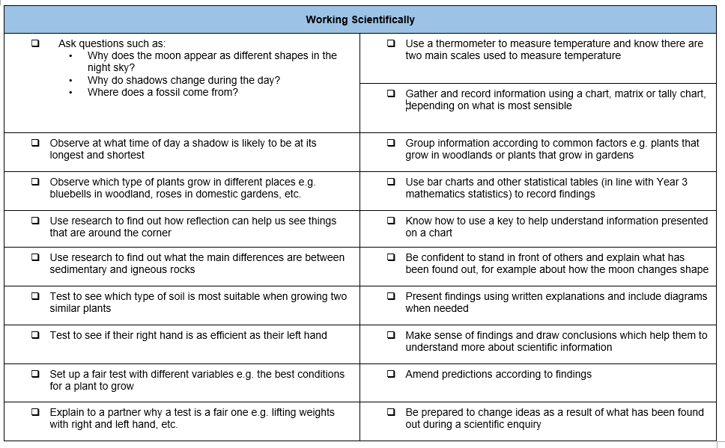

What I need the children to learn | Possible learning experiences
Rocks
Fossil formation
Compare and group rocks
Soil
- Compare and group rocks based on their appearance and physical properties, giving reasons  - Know how soil is made and how fossils are formed  - Know about and explain the difference between sedimentary, metamorphic and igneous rock | Test two rocket types (limestone and not limestone)  Add acid (vinegar) what happens?  Link to acid rain and erosion of land  Visit Robin Hood’s Bay – Find fossils and look at rock face  Look at examples of different rocks  Examine crystal  Sizes to sort

Geography

What I need the children to learn | Possible learning experiences
Locational Knowledge
locate the world’s countries, using maps to focus on Europe (including the location of Russia) and North and South America, concentrating on their environmental regions, key physical and human characteristics, countries, and major cities
- Know the names of and locate at least eight European countries | Map work – differences in two contrasting countries  Rio – New York comparison
Geographical skills and fieldwork
use maps, atlases, globes and digital/computer mapping to locate countries and describe features studied
- Use maps to locate European countries and capitals. | Europe map up in class  Google Earth  Map work – link country shape with names

Computing

What I need the children to learn | Possible learning experiences
Using programs
Pupils should be taught to select, use and combine a variety of software (including internet services) on a range of digital devices to design and create a range of programs, systems and content that accomplish given goals, including collecting, analysing, evaluating and presenting data and information
- understand what computer networks do and how they provide multiple services | https://www.icompute-uk.com/members-area/lks2/index.html and select the Year 3 folder and then the iNetwork unit.

Design Technology

What I need the children to learn | Possible learning experiences
Technical Knowledge
apply their understanding of how to strengthen, stiffen and reinforce more complex structures
understand and use mechanical systems in their products [for example, gears, pulleys, cams, levers and linkages]
understand and use electrical systems in their products [for example, series circuits incorporating switches, bulbs, buzzers and motors]
apply their understanding of computing to program, monitor and control their products.
- know how to strengthen a product by stiffening a given part or reinforce a part of the structure  - use a simple IT program within the design | Sort rocks in Carroll diagrams because of their properties  Use making tape on the floor

Music

New published Music Scheme to arrive shortly but in the meantime please access https://www.bbc.co.uk/teach/ks2-music/zfv96v4 for music ideas for Key Stage 2.

What I need the children to learn | Possible learning experiences
History of music
develop an understanding of the history of music
- recognise the work of at least one famous composer | Comparing different composers, listening to musical performances and comparing
Listen
listen with attention to detail and recall sounds with increasing aural memory
- listen carefully and recognise high and low phrases
Appreciate
appreciate and understand a wide range of high-quality live and recorded music drawn from different traditions and from great composers and musicians
- use musical words to describe a piece of music and compositions
- use musical words to describe what they like and do not like about a piece of music

Physical Education – Follow Real P.E. and supplement with NC P.E. experiences

What I need the children to learn | Possible learning experiences
Athletics
use running, jumping, throwing and catching in isolation and in combination
- run at fast, medium and slow speeds; changing speed and direction  - take part in a relay, remembering when to run and what to do | More sport specific games and competitions  Relays, obstacle courses  Creative games made by children  Links to Real PE 4
Competitive Games
play competitive games, modified where appropriate [for example, badminton, basketball, cricket, football, hockey, netball, rounders and tennis], and apply basic principles suitable for attacking and defending
- be aware of space and use it to support team-mates and to cause problems for the opposition
- know and use rules fairly
Gymnastics
develop flexibility, strength, technique, control and balance [for example, through athletics and gymnastics]
- adapt sequences to suit different types of apparatus and criteria
- explain how strength and suppleness affect performance
Dance
perform dances using a range of movement patterns
- improvise freely and translate ideas from a stimulus into movement
- share and create phrases with a partner and small group
- remember and repeat dance perform phrases
Outdoor and Adventurous Activity
take part in outdoor and adventurous activity challenges both individually and within a team
- follow a map in a familiar context
- use clues to follow a route
- follow a route safely
Evaluate
compare their performances with previous ones and demonstrate improvement to achieve their personal best
- compare and contrast gymnastic sequences
- recognise own improvement in ball games
Real P.E.
Unit 4Creative
- I can make up my own rules and versions of activities. I can respond differently to a variety of tasks or music and I can recognise similarities and differences in movements and expression.
Nigel Carson Sessions

PSHE

What I need the children to learn | Possible learning experiences
Healthy Me | Resource links from: Jigsaw
• Know how exercise affects their bodies  • Know why their hearts and lungs are such  important organs  • Know that the amount of calories, fat and  sugar that they put into their bodies will affect  their health  • Know that there are different types of drugs  • Know that there are things, places and people  that can be dangerous  • Know a range of strategies to keep  themselves safe  • Know when something feels safe or unsafe  • Know that their bodies are complex and need  taking care of | In this Puzzle the class talk about the importance of exercise and how it helps your body to stay healthy. They also talk about their heart and lungs, discuss what they do and that they are very important. The children talk about calories, fat and sugar; they discuss what each of these are and how the amount they consume can affect their health. The class talk about different types of drugs, the ones you take to make you better as well as other drugs. The children think about things, places and people that are dangerous and link this to strategies for keeping themselves safe.  Please see the link below

https://jigsawlivestcmsuk.blob.core.windows.net/umbraco-media/hpkdfhs2/04-ages-7-8-jigsaw-skills-and-knowledge-progression-for-parents.pdf

Religious Education

What I need the children to learn | Possible learning experiences
L2.5
- Why are festivals important to religious communities? Easter focus possibly an R.E. week | Think about times in their own lives when pupils remember and celebrate significant events/people, and why and how they do this. Consider the meanings of the stories behind key religious festivals, e.g Christmas, Easter, Pentecost, Harvest in Christianity, Diwali in Hinduism, Pesach, Rosh Hashanah and Yom Kippur in Judaism, Eid in Islam.  Describe how believers express the meaning of religious festivals through symbols, sounds, actions, story and rituals.

Foreign Languages

What I need the children to learn | Possible learning experiences
Speaking
speak in sentences, using familiar vocabulary, phrases and basic language structures
- name and describe people, a place and an object
- have a short conversation, saying 3 to 4 things
- give response using a short phrase
- start to speak, using a full sentence
Reading
develop accurate pronunciation and intonation so that others understand when they are reading aloud or using familiar words and phrases
- read and understand a short passage using familiar language
- explain the main points in a short passage
- read a passage independently
- use a bilingual dictionary or glossary to look up new words
Writing
broaden their vocabulary and develop their ability to understand new words that are introduced into familiar written material, including through using a dictionary
- write phrases from memory
- write 2-3 short sentences on a familiar topic
- write what they like/dislike about a familiar topic

Cayton Creation

Prepping the gardening beds with topsoils and compost ready for next half term

Cayton Conclusion

Flintstone – Bedrock Movie

English

What I need the children to learn | Possible learning experiences
Reading focus post lock down  Writing focus post lock down  20 sentence types focus post lock down | Writing instructions from prepping the gardening beds.  Geography links with non-chronological reports.  CLPE – What we’ll build – welcoming children back to school, looking at relationships.
Mathematics

What I need the children to learn | Possible learning experiences
Following the White Rose Planning scheme for Spring  Statistics  Bar Charts  Data Analysis  Length  Perimeter | Childrens data, looking at personal date and using it in our analysis.  Measuring the gardening beds and looking at seed placements every …. Cm

