September 2021

Cayton School | Medium Term Curriculum Plan Year 5 – Autumn 2

Learn from yesterday, seek today and aimfor tomorrow

Science Driver: Forces

Key Enquiry: Why does what goes up always come down?

Science Driver

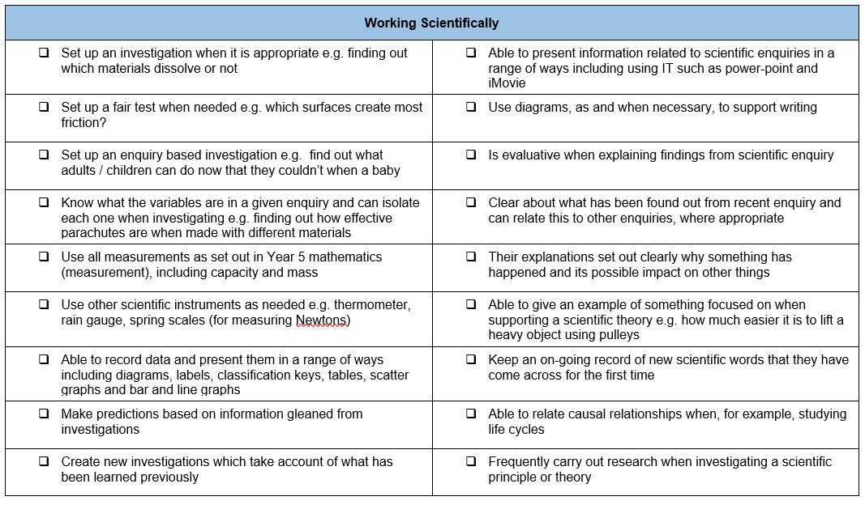

What I need the children to learn | Possible learning experiences
Forces
Gravity
Friction
Forces and motion of mechanical devices
- Know what gravity is and its impact on our lives  - Identify and know the effect of air and water resistance  - Identify and know the effect of friction  - Explain how levers, pulleys and gears allow a smaller force to have a greater effect | Test paper helicopters (discuss about gravity acting down) with different sized blades (templates on-line) to see which falls to the ground quickest  Air resistance will keep the biggest surface area of blades up the longest  Look at videos of professional swimmers – discuss how water resistance has advantages and disadvantages – write explanation  Make toys with levers, pulleys or gears or look at them in everyday life  Sort pictures into each type of lever, pulley or gears  Link instruction writing of a real purpose

Computing

What I need the children to learn | Possible learning experiences
Develop programs
Pupils should be taught to use sequence, selection, and repetition in programs; work with variables and various forms of input and output
- develop a program that has specific variables identified | https://www.icompute-uk.com/members-area/uks2/index.html and select Year 5 and then iProgram unit

Geography

What I need the children to learn | Possible learning experiences
Locational Knowledge
locate the world’s countries, using maps to focus on Europe (including the location of Russia) and North and South America, concentrating on their environmental regions, key physical and human characteristics, countries, and major cities
- Know the names of a number of European capitals  - Know the names of, and locate, a number of South or North American countries | L.A/ Russia comparison  Pollution effects of humans on locality  Quiz making – study of individual countries  Focus on Americas  Google Earth landscapes

Music

New published Music Scheme to arrive shortly but in the meantime please access https://www.bbc.co.uk/teach/ks2-music/zfv96v4 for music ideas for Key Stage 2.

What I need the children to learn | Possible learning experiences
Listen
listen with attention to detail and recall sounds with increasing aural memory
- repeat a phrase from the music after listening intently.

Design Technology

What I need the children to learn | Possible learning experiences
Designing
use research and develop design criteria to inform the design of innovative, functional, appealing products that are fit for purpose, aimed at particular individuals or groups

generate, develop, model and communicate their ideas through discussion, annotated sketches, cross-sectional and exploded diagrams, prototypes, pattern pieces and computer-aided design

- come up with a range of ideas after collecting information from different sources  - produce a detailed, step-by-step plan  - explain how a product will appeal to a specific audience  - design a product that requires pulleys or gears | Design own helicopter/ gyrocopter  Design pulleys
Making
select from and use a wider range of tools and equipment to perform practical tasks [for example, cutting, shaping, joining and finishing], accurately

select from and use a wide range of materials and components, including construction materials, textiles and ingredients, according to their functional properties and aesthetic qualities
- use a range of tools and equipment competently  - make a prototype before making a final version  - make a product that relies on pulleys or gears | What material makes best for a pulley
Evaluating
investigate and analyse a range of existing products

evaluate their ideas and products against their own design criteria and consider the views of others to improve their work

understand how key events and individuals in design and technology have helped shape the world
- suggest alternative plans; outlining the positive features and draw backs  - evaluate appearance and function against original criteria | Go back to original design brief and evaluate it with experiment
Technical Knowledge
apply their understanding of how to strengthen, stiffen and reinforce more complex structures
understand and use mechanical systems in their products [for example, gears, pulleys, cams, levers and linkages]

understand and use electrical systems in their products [for example, series circuits incorporating switches, bulbs, buzzers and motors]

apply their understanding of computing to program, monitor and control their products.
- links scientific knowledge to design by using pulleys or gears  - uses more complex IT program to help enhance the quality of the product produced | Gravity, force, friction, air resistance, buoyancy, magnetism

Physical Education – Follow Real P.E. and supplement with NC P.E. experiences

What I need the children to learn | Possible learning experiences
Athletics
use running, jumping, throwing and catching in isolation and in combination
- controlled when taking off and landing
- throw with increasing accuracy
- combine running and jumping
Competitive Games
play competitive games, modified where appropriate [for example, badminton, basketball, cricket, football, hockey, netball, rounders and tennis], and apply basic principles suitable for attacking and defending
- gain possession by working a team and pass in different ways
- choose a specific tactic for defending and attacking
- use a number of techniques to pass, dribble and shoot
Gymnastics
develop flexibility, strength, technique, control and balance [for example, through athletics and gymnastics]
- make complex extended sequences
- combine action, balance and shape
- perform consistently to different audiences
Dance | X2 weeks after Real PE
perform dances using a range of movement patterns
- compose own dances in a creative way  - perform dance to an accompaniment  - dance shows clarity, fluency, accuracy and consistency | Group/ Pair dancing to a count  Links to Real PE 2
Outdoor and Adventurous Activity
take part in outdoor and adventurous activity challenges both individually and within a team
- follow a map into an unknown location
- use clues and a compass to navigate a route
- change route to overcome a problem
- use new information to change route
Evaluate
compare their performances with previous ones and demonstrate improvement to achieve their personal best
- pick up on something a partner does well and also on something that can be improved
- know why own performance was better or not as good as their last
Real P.E.
Unit 2Creative
- I can respond imaginatively to different situations adapting and adjusting my skills, movements or tactics so they are different from or in contrast to others.

Nigel Carson Sessions

PSHE

What I need the children to learn | Possible learning experiences
Celebrating Difference | Resource links from: Jigsaw
• Know what culture means  • Know that differences in culture can  sometimes be a source of conflict  • Know what racism is and why it is  unacceptable  • Know that rumour spreading is a form of  bullying on and offline  • Know external forms of support in regard to  bullying e.g. Childline  • Know that bullying can be direct and indirect  • Know how their life is different from the lives  of children in the developing world. | In this Puzzle (unit) the class explore culture and cultural differences. They link this to racism, talking about what it is and how to be aware of their own feelings towards people from different cultures. They revisit the topic of bullying and discuss rumour spreading and name-calling. The children talk about direct and indirect bullying as well as ways to encourage children to not using bullying behaviours. The class talk about happiness regardless of material wealth and respecting other people’s cultures.  See the link below.

https://jigsawlivestcmsuk.blob.core.windows.net/umbraco-media/s1slj10y/06-ages-9-10-jigsaw-skills-and-knowledge-progression-for-parents.pdf

Religious Education

What I need the children to learn | Possible learning experiences
U2.4
- If God is everywhere, why go to a place of worship? Possible R.E. week or fortnight with a focus on a visit to the church and teh mandir | Find out some of the key features of places of worship: e.g. some differences between Anglican and Baptist churches; mandir; differences between an Orthodox and a Reform synagogue.  Explore the duty of pilgrimage in Hinduism, which is seen as a wider part of worship. This concerns the need for Hindus to be seen by the deity worshipping at a particular shrine. Does this mean that God is concentrated more intensely in particular places?  Can pupils talk about a place where people might say or feel God is somehow more ‘present’? What is special about these places?

Foreign Languages

What I need the children to learn | Possible learning experiences
Speaking
speak in sentences, using familiar vocabulary, phrases and basic language structures
- hold a simple conversation with at least 4 exchanges
- use knowledge of grammar to speak correctly
Reading
develop accurate pronunciation and intonation so that others understand when they are reading aloud or using familiar words and phrases
- understand a short story or factual text and note the main points
- use the context to work out unfamiliar words
Writing
broaden their vocabulary and develop their ability to understand new words that are introduced into familiar written material, including through using a dictionary
- write a paragraph of 4-5 sentences
- substitute words and phrases

Cayton Creation
Car ramp experiment

Cayton Conclusion

Share what we have learnt so far as a PowerPoint

English

What I need the children to learn | Possible learning experiences

Mathematics

What I need the children to learn | Possible learning experiences

