September 2021

Cayton School | Medium Term Curriculum Plan Year 5 – Summer 1

Learn from yesterday, seek today and aimfor tomorrow

HistoryDriver: Vikings

Key Enquiry: Why did the Vikings win most battles against the Anglo-Saxons?

HistoryDriver

What I need the children to learn | Possible learning experiences
CHRONOLOGY
(Stone age to 1066)
To include:
Stone age to Iron age
Romans
Anglo-Saxons
Vikings
- Know where the Vikings originated from and show this on a map  - Know that the Vikings and Anglo-Saxons were often in conflict  - Know why the Vikings frequently won battles with the Anglo-Saxons | Plot on a timeline  Yorkshire Murton Park ‘Viking for the day’ visit – covers Viking life, mock battle with Anglo-Saxons and more  Writing, debates, role-play, photographs, artefacts

Science

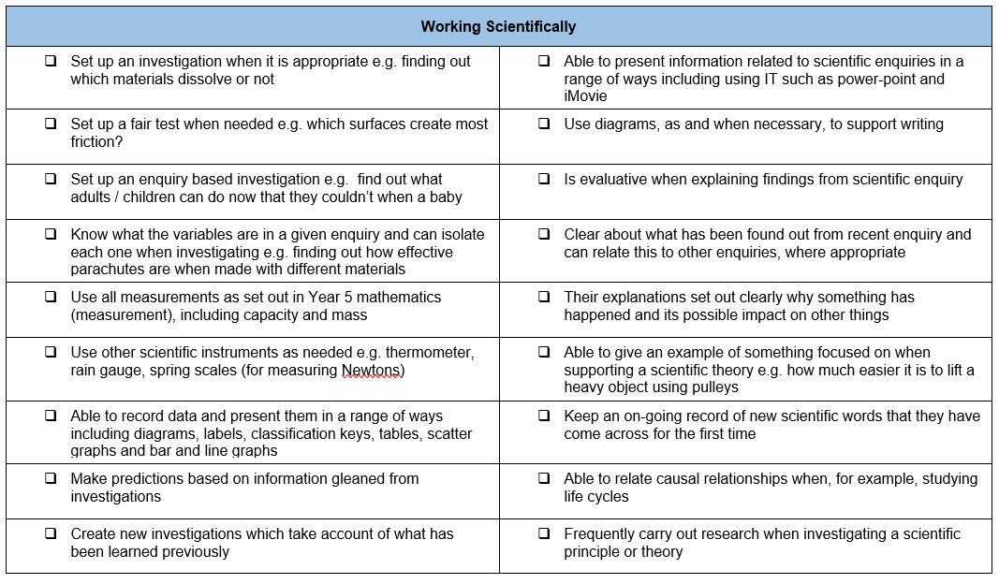

What I need the children to learn | Possible learning experiences
All living things and their habitats
Life cycles – plants and animals
Reproductive processes
Famous naturalists
- Know the life cycle of different living things e.g. mammal, amphibian, insect and bird  - Know the differences between different life cycles  - Know the process of reproduction in plants including sexual and asexual reproduction  - Know the process of reproduction in animals | Look at the life cycles within these categories – practically could have butterflies/ tadpoles  Progress to understand sexual (male and female plant required) and asexual (one parent plant needed – potatoes, strawberries starfish) reproduction
Animals, including humans
Changes as humans develop from birth to old age

- Create a timeline to indicate stages of growth in humans | Can they make a timeline of someone in their family – mum, dad, grandparents – use photographs of them to order, look in more detail about the changes – specifically hormones – just talk at this stage about chemicals in the body, older people skin cells, getting older, hair, growth – losing hair

Computing

What I need the children to learn | Possible learning experiences
Using programs
Pupils should be taught to select, use and combine a variety of software (including internet services) on a range of digital devices to design and create a range of programs, systems and content that accomplish given goals, including collecting, analysing, evaluating and presenting data and information
- combine sequences of instructions and procedures to turn devices on and off | Use of Micro-bit Robots with reference to:  https://www.icompute-uk.com/members-area/uks2/index.html and select Year 5 and then iAlgorithm unit
Create programs
Pupils should be taught to design, write and debug programs that accomplish specific goals, including controlling or simulating physical systems; solve problems by decomposing them into smaller parts
- use technology to control an external device | Use of Micro-bit Robots with reference to:  https://www.icompute-uk.com/members-area/uks2/index.html and select Year 5 and then iAlgorithm unit

Art

What I need the children to learn | Possible learning experiences
Drawing, painting and sculpture
improve their mastery of art and design techniques, including drawing, painting and sculpture with a range of materials [for example, pencil, charcoal, paint, clay]
- know how to use shading to create mood and feeling  - know how to organise line, tone, shape and colour to represent figures and forms in movement.  - know how to express emotion in art  - know how to create an accurate print design following given criteria. | Draw Viking long boat  3D shields  Clay Viking faces

Physical Education – Follow Real P.E. and supplement with NC P.E. experiences

What I need the children to learn | Possible learning experiences
Athletics
use running, jumping, throwing and catching in isolation and in combination
- controlled when taking off and landing
- throw with increasing accuracy
- combine running and jumping
Competitive Games
play competitive games, modified where appropriate [for example, badminton, basketball, cricket, football, hockey, netball, rounders and tennis], and apply basic principles suitable for attacking and defending
- gain possession by working a team and pass in different ways
- choose a specific tactic for defending and attacking
- use a number of techniques to pass, dribble and shoot
Gymnastics
develop flexibility, strength, technique, control and balance [for example, through athletics and gymnastics]
- make complex extended sequences
- combine action, balance and shape
- perform consistently to different audiences
Dance
perform dances using a range of movement patterns
- compose own dances in a creative way
- perform dance to an accompaniment
- dance shows clarity, fluency, accuracy and consistency
Outdoor and Adventurous Activity
take part in outdoor and adventurous activity challenges both individually and within a team
- follow a map into an unknown location  - use clues and a compass to navigate a route  - change route to overcome a problem  - use new information to change route | Orienteering, cross-country, obstacle courses, building stamina  Links to Real PE 5
Evaluate
compare their performances with previous ones and demonstrate improvement to achieve their personal best
- pick up on something a partner does well and also on something that can be improved
- know why own performance was better or not as good as their last
Real P.E.
Unit 5 Health and Fitness
- I can self select and perform appropriate warm up and cool down activities. I ca identify possible dangers when planning an activity.

Nigel Carson Sessions

PSHE

What I need the children to learn | Possible learning experiences
Relationships | Resource links from: Jigsaw
• Know that a personality is made up of  many different characteristics, qualities and  attributes  • Know that belonging to an online community  can have positive and negative consequences  • Know that there are rights and responsibilities  in an online community or social network  • Know that there are rights and responsibilities  when playing a game online  • Know that too much screen time isn’t healthy  • Know how to stay safe when using technology to communicate with friends. | Children learn about the importance of self-esteem and ways this can be boosted. This is important in an online context as well as off-line, as mental health can be damaged by excessive comparison with others. This leads onto a series of lessons that allow the children to investigate and reflect upon a variety of positive and negative online/ social media contexts including gaming and social networking. They learn about age -limits and also age-appropriateness. Within these lessons, children are taught the SMARRT internet safety rules and they apply these in different situations. Risk, pressure and influences are revisited with a focus on the physical and emotional aspects of identifying when something online or in social media feels  uncomfortable or unsafe. Children are taught about grooming and how people online can pretend to be whoever they want. Rights, responsibilities and respect are revisited with an angle on technology use. Screen time is also discussed and children find ways to reduce their own screen time. This Puzzle aims to help children to be more discerning when viewing anything online or on social media.  See the link below

https://jigsawlivestcmsuk.blob.core.windows.net/umbraco-media/s1slj10y/06-ages-9-10-jigsaw-skills-and-knowledge-progression-for-parents.pdf

Religious Education

What I need the children to learn | Possible learning experiences
U2.6
- What does it mean to be a Muslim in Britain today? | Summer 1 and Summer 2  Explore the practice, meaning and significance of the Five Pillars of Islam as an expression of ibadah (worship and belief in action). Shahadah (belief in one God and his Prophet); salat (daily prayer); sawm (fasting); zakat (alms giving); hajj (pilgrimage). How do these affect the lives of Muslims, moment by moment, daily, annually, in a lifetime?  Think about and discuss the value and challenge for Muslims of following the Five Pillars, and how they might make a difference to individual Muslims and to the Muslim community (Ummah). Investigate how they are practised by Muslims in Britain today. Consider what beliefs, practices and values are significant in pupils’ lives.

Foreign Languages

What I need the children to learn | Possible learning experiences
Speaking
speak in sentences, using familiar vocabulary, phrases and basic language structures
- hold a simple conversation with at least 4 exchanges
- use knowledge of grammar to speak correctly
Reading
develop accurate pronunciation and intonation so that others understand when they are reading aloud or using familiar words and phrases
- understand a short story or factual text and note the main points
- use the context to work out unfamiliar words
Writing
broaden their vocabulary and develop their ability to understand new words that are introduced into familiar written material, including through using a dictionary
- write a paragraph of 4-5 sentences
- substitute words and phrases

Cayton Creation
Design my own Viking shield

Cayton Conclusion

Battle as Anglo Saxons Vs Vikings

English

What I need the children to learn | Possible learning experiences

Mathematics

What I need the children to learn | Possible learning experiences

