Summer 1
Possible Themes & Interests  (based on interests the children have had in past years) |  | Transport/Journeys Plants - sunflowers Queens Jubilee life cycles  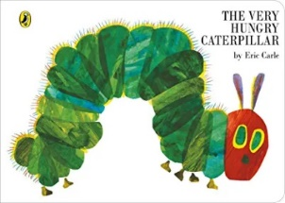
Suggested Texts | Books following possible themes | 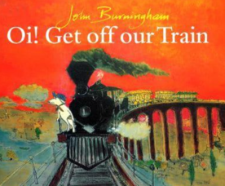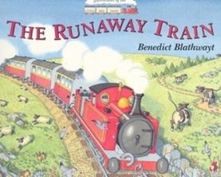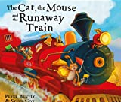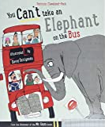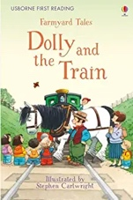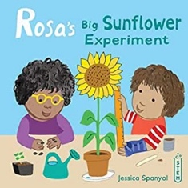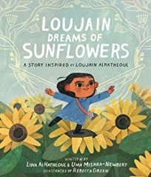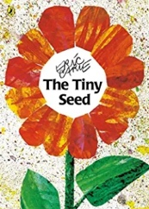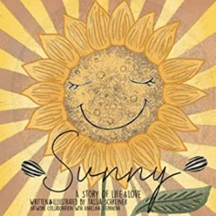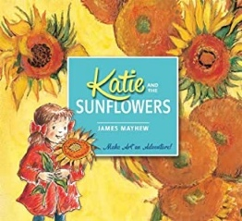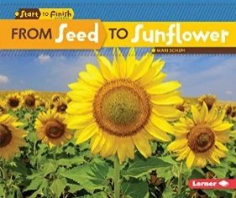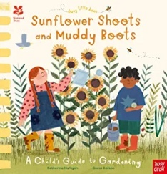  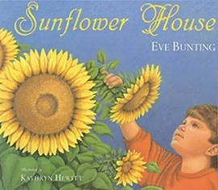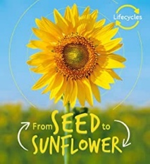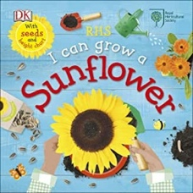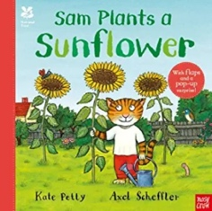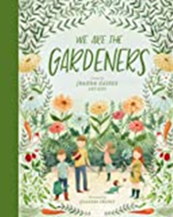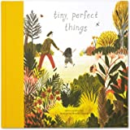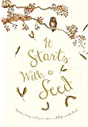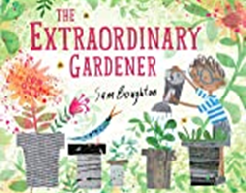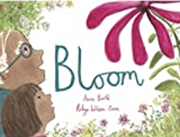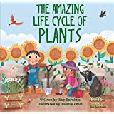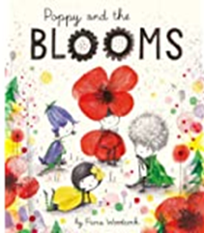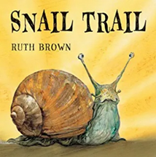  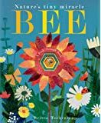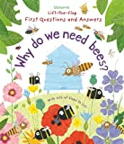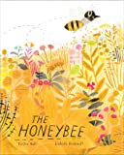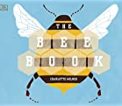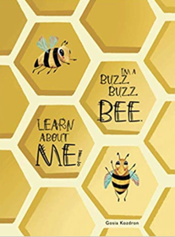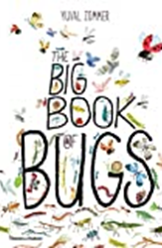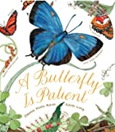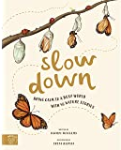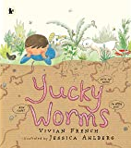  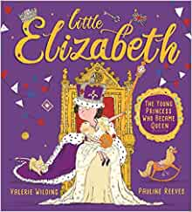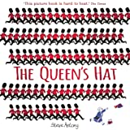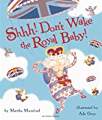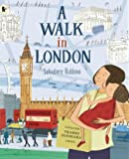
 | Summer 1  Literacy Texts | 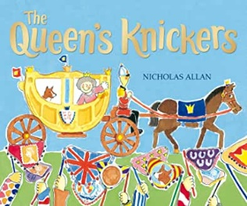  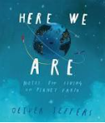
Child led interests covered during the half term:

Prime Areas

Area of learning |  | Objectives/skills |  | Revisit/ongoing  throughout the year | Best fit assessment
 |  |  |  |  | On track | not on track | extra focus assessment needed
Communication and Language |  | Listening:  Listen to and understand instructions about what they are doing, whilst busy with another task  Attention:  Listen and continue with an activity for a short time.  Respond:  Keep play going in response to the ideas of others and engage in conversation relevant to play theme.  Ask and answer ‘what’, ‘where’, ‘when’, and ‘what could we do next’ questions.  Listen to and talk about selected non-fiction to develop a deep familiarity with new knowledge and vocabulary.  Understanding:  Carry out a series of 3 directions. Show familiarity with selected non-fiction by using new knowledge and vocab in conversation and play. Understand ‘how’, ‘why’ and ‘where’ questions.  Speaking:  Recount an event in the correct order and some detail.  Give details that they know are important and will influence the listener.  Express ideas about feelings and experiences.  Articulate their ideas in well-formed sentences.  Show that they can use language to reason and persuade E.g. “Can I go outside because someone has just come in. There is one space?” “I can go outside now as Mrs Oliver has opened the area”. |  | Learn new vocabulary Use new vocabulary in different contexts.  Use new vocabulary through the day in discussions and conversations.  Learn new rhymes, poems, and songs.  Listen to and talk about stories to build familiarity  and understanding.  Listen to and talk about selected non-fiction to develop a deep familiarity with new knowledge and vocabulary.
Personal, Social  and Emotional Development |  | Express feelings:  Beginning to know that children think and respond in different ways to them.  Manage behaviour:  Can follow instructions, requests, and ideas in a range of situations.  Self-awareness:  Can talk about their own abilities positively.  Independence:  Confident to try new activities and say why they like some activities more than others.  Show resilience and perseverance, a belief that with more effort or with a different approach success will occur.  Understands rules linked to road safety.  Can follow directions with 3 parts.  Collaboration:  Know it is important for all of us to keep safe when using and transporting tools, equipment, and resources.  Social skills:  Can be considerate to the needs of others, beginning to respect a different point of view and work together in collaboration.  Jigsaw theme – Relationships  Covering - identifying some of the jobs I do in my family, how to make friends to stop myself from feeling lonely, thinking of ways to solve problems and stay friends, starting to understand the impact of unkind words, using ‘Calm Me’ Time to manage my feelings, know how to be a good friend.  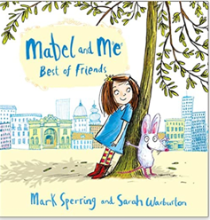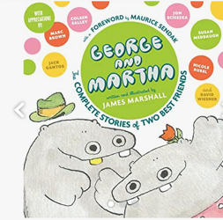  - My Family and Me!  - Make friends, make friends, never ever break friends Part 1 (George and Martha book)  - Make friends, make friends, never ever break friends Part 2 (Use Mabel and Me Best friends book)  - Falling Out and Bullying Part 1  - Falling Out and Bullying Part 2  - 6. Being the best friends we can be  RE - Key question F4: Which times are special and why? |  | Continue to develop skills of using gestures, non-verbal communication, facial expressions, body language, appropriate language, and vocabulary; to listen to others, speak to peers and adults and engage in discussions in a positive way.
Physical  Development |  | Develop the foundations of a handwriting style which is fast, accurate and efficient.  Continue to develop their small motor skills so that they can use a range of tools competently, safely, and confidently. Suggested tools: pencils for drawing and writing, paintbrushes, scissors, knives, forks, and spoon.  Fine motor skills are the small movements used for control and precision during activities.  It is important to recognise that the development of fine motor skills happens through daily access to resources, activities and opportunities provided through continuous provision e.g., threading, play dough, building and creating, colouring, puzzles etc. All areas of learning are interconnected and not all learning has a predetermined outcome. |  | Continue to develop overall body-strength, balance, co-ordination, and agility through use of outdoor play equipment continuously available. | Complete separate fine motor writing assessment.  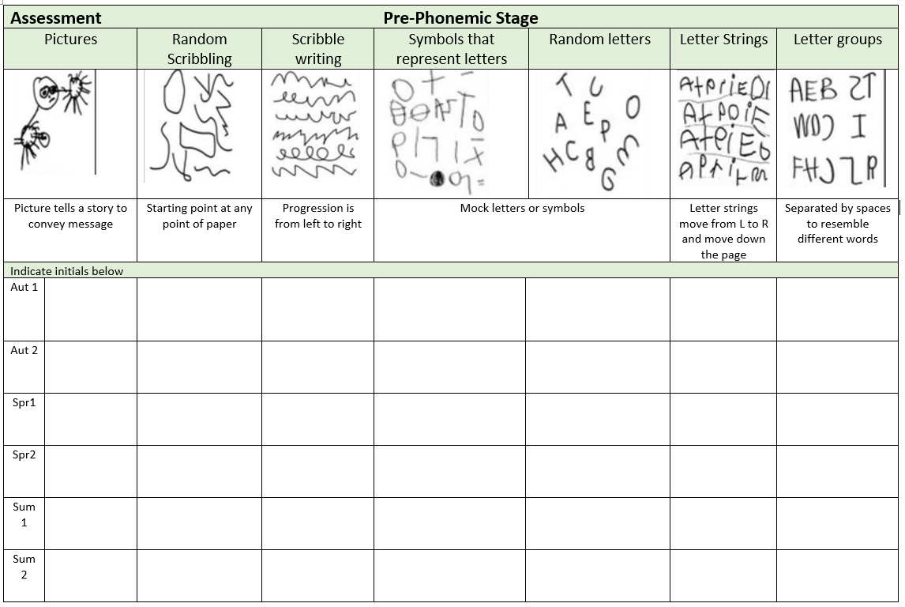
Develop the overall body strength, co-ordination, balance, and agility needed to engage successfully with future physical education sessions and other physical disciplines including dance, gymnastics, sport, and swimming.

Combine different movements with ease and fluency.

REAL PE FOCUS – Physical Cog
I can move confidently in different ways. (expected)
Applying Physical Cog Focus – Performing a single skill or movement with some control, performing a range of skills and link two movements together.
Coordination skill: Sending and Receiving
Agility skill: Reaction/Response
Specific Areas
Literacy |  | COMPREHENSION  Correctly sequence a story or event using pictures and/or captions.  Make simple, plausible suggestions about what will happen next in a book they are reading.  Know the difference between different types of texts (fiction, nonfiction, poetry)  Make inferences to answer a question beginning 'Why do you think…?' in a picture book that has been read to them, where answer is clearly signposted.  Play influenced by experience of books - gestures and actions used to act out a story, event or rhyme from text or illustrations. |  |  |  |  | .
 |  | WORD READING  Read some letter groups that each represent one sound and say sounds for them.  Read simple phrases and sentences made up of words with known letter–sound correspondences and, where necessary, a few exception words. |  | Re-read books to build up their confidence in word reading, their fluency and their understanding and enjoyment. Read books consistent with their phonic knowledge.
WRITING
Emergent writing:
Continue to build on knowledge of letter sounds to build words in writing. Use writing in play. Use familiar words in their writing.
Composition:
Begin to write a simple sentence/caption may include a full stop.
Spelling:
Spell words by drawing on knowledge of known grapheme correspondences.
Make phonetically plausible attempts when writing more complex unknown words.
Handwriting:
Form most lower-case letters correctly, starting and finishing in the right place, going the right way round and correctly orientated.
Include spaces between words.
Helicopter stories progression:
Child takes the pen more and more, until eventually they are writing complete phrases. May still need a phonics mat to support.

Phonics |  | Phase 2  Children to be taught the phase 2 phonemes in the following order alongside the written grapheme:  Set 1 – s,a,t,p  Set 2 – i, n, m, d  Set 3 – g, o, c,k  Set 4 – ck, e, u, r  Set 5 – h, b, f, ff, l, ll, ss  Children to be taught to orally blend and segment CVC words using the phase 2 phonemes  Children to be taught to blend and read the following high frequency words alongside the set of phonemes:  Set 1 – a, at, as  Set 2 – is, it, in, an, I  Set 3 – and, on, no, to, can, no, go  Set 4 - into, get, got, the, back, put  Set 5 – his, him, of, dad, mum, up  Phase 3  Consolidate phase 2 and 3 skills.  Know trigraphs ear, ure, air  Know vowel digraph er  Read tricky words they, her, all, are  Continue to apply knowledge of blending and segmenting to reading and spelling simple two-syllable words and captions.  Write more graphemes from memory and write a simple sentence using phonic knowledge.  One group accessing phase 4:  Children must have opportunities to:  Revise all Phase 2 and 3 phonemes  Read and write CCVC and CVCC words  Practise reading and spelling previously taught high frequency words  Read and spell two-syllable words  Learn to spell the common exception words: we, me, he, be, she, they, all, are, my, her  Read common exception words: said, so, was, you have, like, some, come, were, there, little, one, do, when, out, what  Read decodable words: went, from, it’s, just, help, children |  | Continue to develop general sound discrimination, rhythm and rhyme, alliteration, voice sounds, oral blending, and segmenting.
Area of learning |  | Objectives/skills |  | Revisit/ongoing  throughout the year | Best fit assessment
 |  |  |  |  | On track | not on track | extra focus assessment needed
Mathematics |  | To 20 and beyond  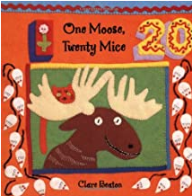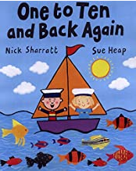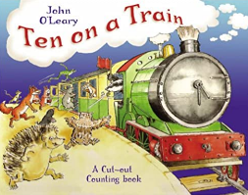  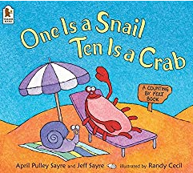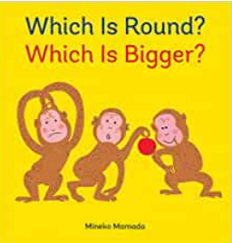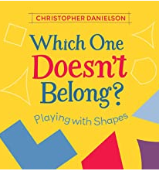 |  | Subitising:  Continue to provide regular opportunities to instantly recognise small quantities e.g. dice, dominoes, bingo.  Counting:  Continue to apply counting principles when counting forwards and backwards within 10.  Continue to support counting principles to find how many in a set or count out a required number of objects from a larger group.  Composition:  Continue to develop understanding that all quantities are composed of smaller quantities.  Sorting and Matching:  Continue to notice similarities and differences in matching and sorting objects in new contexts.  Comparing and Ordering:  Provide regular opportunities to compare and order quantities and measures.  Continue to make comparisons by lining items up with 1:1 correspondence to compare directly.
 |  | Building numbers beyond 10 | Use a range of resources e.g., 10 frames, number shapes, tower cubes, rekenreks, bead strings show a full 10s and part of the next 10.  Recognise numbers 1-9 repeat after every full 10. So, 1 full ten and 1. 1 full ten and 2 etc. Then 2 full tens and 1, 2 full tens and 2 and so on.
 |  | Counting Patterns Beyond 10 | Provide representations which clearly show the full 10s and the part of 10 e.g., 14 is one full ten and four.  Count on and back from different starting points, say what comes before or after a given number and to place sequences of numbers in order. Challenge to find larger numbers on number tracks and 100 squares.
 |  | Spatial Reasoning | Provide opportunities to select and rotate shapes to fill a given space. Say why they chose a particular shape and why a different one wouldn’t fit.  Provide opportunities to match arrangements of shapes, use positional language to describe where shapes are in relation to each other. Provide opportunities for children to select shapes to complete picture boards or tangram outlines.
Understanding the World |  | It is important to recognise learning does not always fit into boxes. Our play-based and child-centred approaches encourage learning to follow where the child’s interest and curiosity leads. Through a balance of guided, planned teaching and pursuing children's own learning within an enabling environment the children will begin to make sense of the physical world and their community.  This document shows the knowledge, skills and understanding what we plan to teach and the planned for experiences we will provide. This is in addition to following children's interests and their curiosity about their world.  Chronology: Recount an event, orally, pictorial and/or with captions.  Enquiry: Talk about key roles people have in society both in the present and past. Name and describe people who are  familiar to them within their community e.g., police, fire service, doctors, dentist.  Respect: Understand that some places are special to members of their community.  Mapping: Draw information from a simple map and identify landmarks of our local area walk.  Enquiry:  Comment and ask questions about the different parts of the local community. E.g., weather, hill, house, farm, church, shop. Use photos and pictures to locate places and place on a simple map.  Find out about their local area by talking to people, examining photographs, and visiting local places.  Understand the key features of the life cycle of a plant or animal. |  | Communication: Comment on what they notice about the environment where they live and understand the effect of the changing seasons on the natural world around them. Describe what they see, hear, and feel outside.  Observation: Explore the natural world around them by taking part in weekly forest school inspired ‘Nature School’ sessions and making observations and drawing pictures of animals and plants. Understand the need to respect and care for the natural environment and all living things.
Expressive Arts and Design |  | Children will experience and develop a range of creative, artistic skills. The children will have daily, continuous access to a wide range of open ended, ambiguous resources allowing the opportunity to explore, experiment and develop their own creativity. They will have the opportunity to create collaboratively sharing Ideas and resources as well on solo work. Throughout the year the children will have the opportunity to return to and build on their previous learning, refining ideas and developing their ability to represent them. In addition, specific skills and/or experiences will be planned (see below).  Marking Making/Drawing: observational drawing - Sunflowers  Show accuracy and care in their drawing.  Colour: identifying shades of colour and how to make different shades.  Painting: explore working with paint on different surfaces and in different ways i.e., coloured, sized, and shaped paper. Explore using different brush types.  Printing: symmetrical printing - butterflies as inspiration. (Linked to Hungry caterpillar)  Textiles/materials: Weaving (natural and manmade materials)  3D Work: Making own props/puppets to retell a story. Folding techniques e.g., fans, aeroplanes, books. Choosing materials for effect e.g., feather headdress  Cutting Skills: use scissors independently.  Artist Study: Van Gogh  Poetry Basket:  I have a little frog Dance  Five little peas Pitter Patter  Monkey Babies If I were so very small  Being Imaginative:  Invent, adapt and recount narratives and stories with peers and their teacher. Creates representations of both imaginary and real-life ideas, events, people and objects.  Uses combinations of art forms, e.g. moving and singing, making and dramatic play,  drawing and talking, constructing, and mapping |  | Listen attentively, move to and talk about music, expressing their feelings and responses.  Explore, use, and refine a variety of artistic effects to express their ideas and feelings.  Explore and engage in music making and dance, performing solo or in groups.

