Summer 2
Possible Themes & Interests  (based on interests the children have had in past years) |  | Summer/hot places seaside/mermaids/pirates carnival ourselves  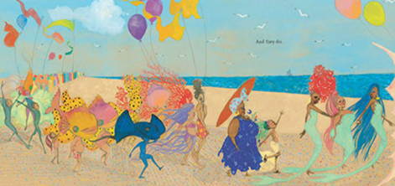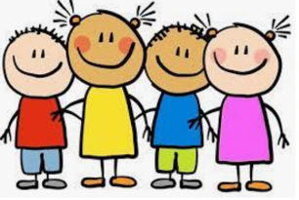
Suggested Texts | Books following possible themes | 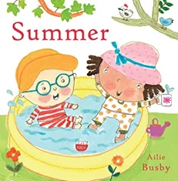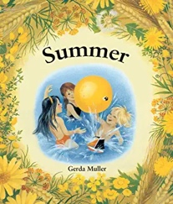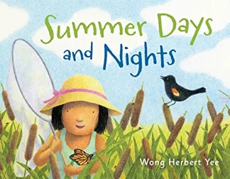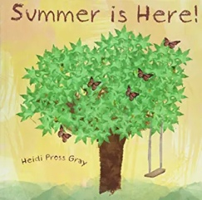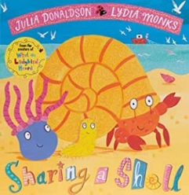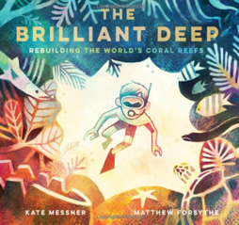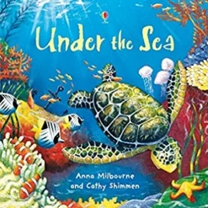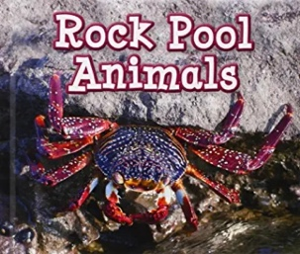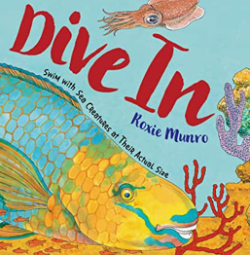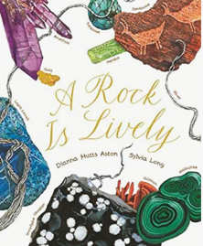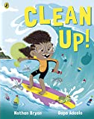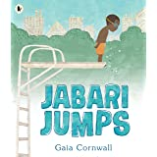  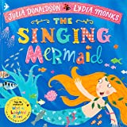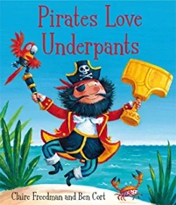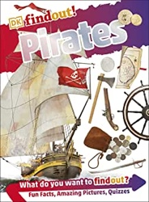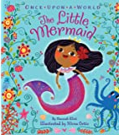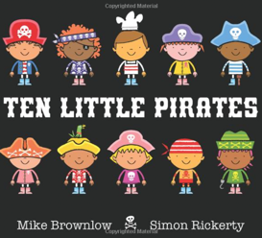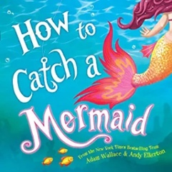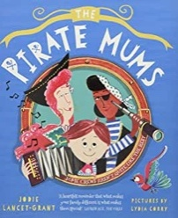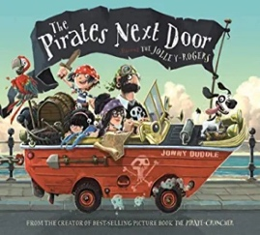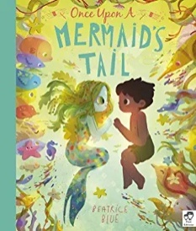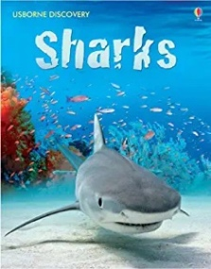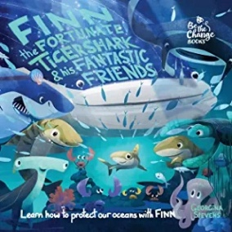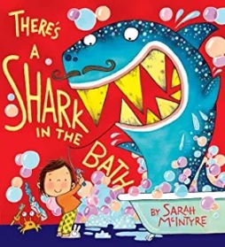  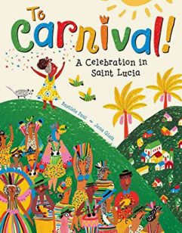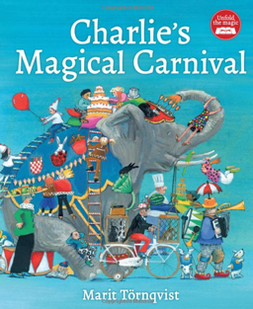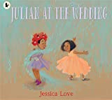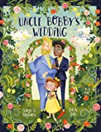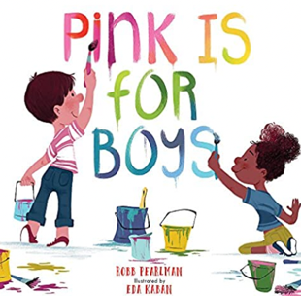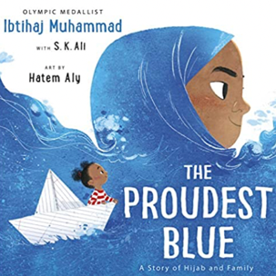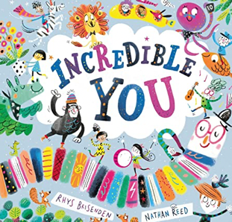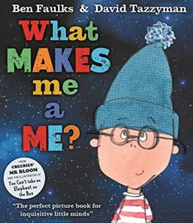
 | Summer 2  Literacy Texts | 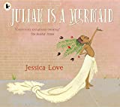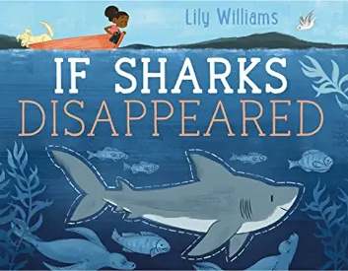
Prime Areas

Area of learning |  | Objectives/skills |  | Revisit/ongoing  throughout the year | Best fit assessment
 |  |  |  |  | On track | not on track | extra focus assessment needed
Communication and Language |  | Listening:  Listen attentively and respond to what they hear with relevant questions, comments, or actions.  Attention:  Attend to others in play, play co-operatively and can pretend to be someone else talking.  Games can be quite elaborate and detailed.  Respond:  Make comments about what they have heard and ask questions to clarify thinking.  Respond by asking if unsure and uses words specifically to make meaning clear E.g. “I didn’t want my yellow gloves; I wanted the spotty ones that match my hat”  Understanding:  Retell a story with some exact repetition and in their own words.  Understand that words can be put into groups or categories, and give examples from each category E.g., Animals, transport, food, etc.  Understand a range of words to describe the idea of time, shape, texture, size and know in which context to use them E.g. Soon, early, and late; square, triangle and circle; soft, hard, and smooth.  Name objects, characters, and animals from a description E.g. “It lives in the jungle and is fierce with big teeth and is stripy.”  Speaking:  Articulate and create an imaginary story of their own in play or in writing.  Speak clearly in well-formed sentences of 8 words or more in length with some detail. E.g., “I made a big round pizza with tomato, cheese and ham on top”  Use new vocabulary in different contexts.  Use past, present, and future tenses in conversation with peers and adults.  Use conjunctions to extend and articulate their ideas, join phrases with words such as ‘if’, ‘because’, ‘so’, ‘could’ E.g. “I can have a biscuit if I eat all my dinner” |  | Learn new vocabulary Use new vocabulary in different contexts.  Use new vocabulary through the day in discussions and conversations.  Learn new rhymes, poems, and songs.  Listen to and talk about stories to build familiarity  and understanding. |  | CSS/LW/LA/EB/SRB/AB
Personal, Social  and Emotional Development |  | Express feelings:  Understands some strategies to deal with anger and frustration.  Able to identify and moderate own feelings.  Can negotiate with others to solve problems and take steps to resolve conflict and think about the perspectives of others.  Manage behaviour:  Engage in challenges and take responsibility for their own learning. Plan, adapt, persist, and review own progress.  Self-awareness:  See themselves as a unique and valued individual, talk about self, abilities, and interests in positive terms.  Independence:  Can seek out a challenge and enjoy the process. Understands what it means to keep healthy, has knowledge of food  groups including healthy foods and knows exercise keeps the body healthy.  Collaboration:  Can take account of the ideas of others about how to organise and activity. Can show sensitivity to others’ needs and  feelings.  Social skills:  Can resolve conflict and able to compromise. Take responsibility for their own actions.  Show awareness of how their actions may impact on others, know that other children think and respond in different  ways to them.  Jigsaw theme – Changing Me  Covering – Naming parts of the body, knowing what foods are healthy, understanding that we grow from babies to adults, expressing feelings about moving to Year 1, talking about worries and sharing best bits of the Reception year.  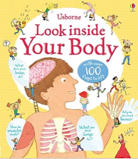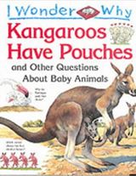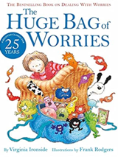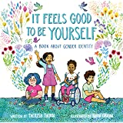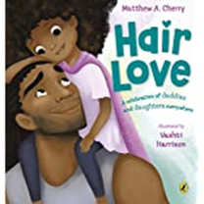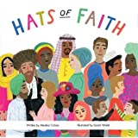  RE - Key question: What is special about our world and why? |  | Continue to develop communication skills of using gestures, non-verbal communication, facial expressions, body language, appropriate language, and vocabulary; to listen to others, speak to peers and adults and engage in discussions in a positive way. |  | FM/AM/LW/LAEB/SRB
Physical  Development |  | Fine Motor  Develop the foundations of a handwriting style which is fast, accurate and efficient.  Continue to develop their small motor skills so that they can use a range of tools competently, safely, and confidently. Suggested tools: pencils for drawing and writing, paintbrushes, scissors, knives, forks, and spoon.  Fine motor skills are the small movements used for control and precision during activities.  It is important to recognise that the development of fine motor skills happens through daily access to resources, activities and opportunities provided through continuous provision e.g., threading, play dough, building and creating, colouring, puzzles etc. All areas of learning are interconnected and not all learning has a predetermined outcome. |  | Develop the overall body strength, co-ordination, balance, and agility needed to engage successfully with future physical education sessions and other physical disciplines including dance, gymnastics, sport, and swimming.  Use their core muscle strength to achieve a good posture when sitting at a table or sitting on the floor.  Develop overall body-strength, balance, co-ordination, and agility. | Complete separate fine motor writing assessment.  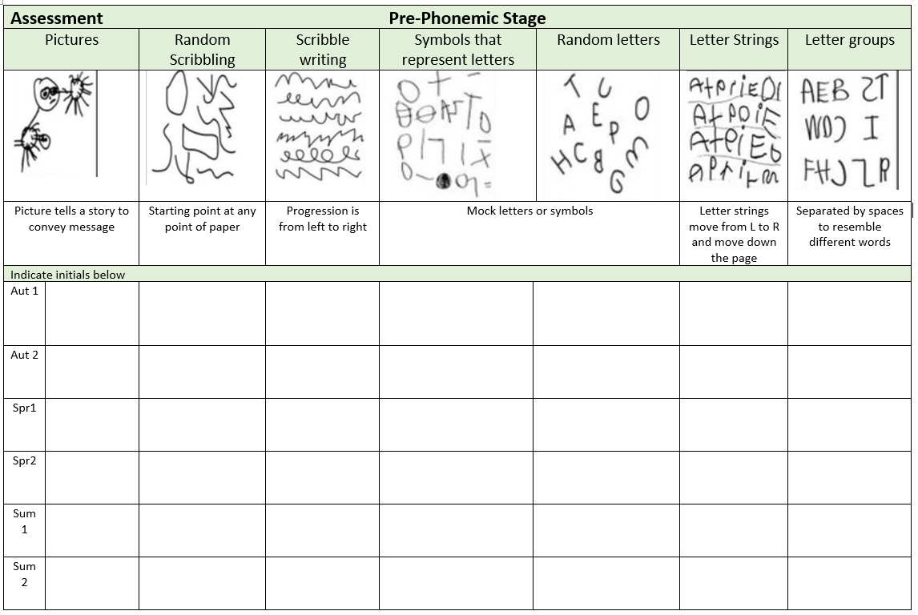
 |  | Gross motor  Confidently and safely use a range of large and small apparatus indoors and outside, alone and in a group.  REAL PE FOCUS  Health and Fitness Cog Focus – Aware of why exercise is important for good health.  Agility skill: Ball chasing  Static balance skill: Floor work |  |  |  | LW/LA/SRB
Specific Areas
Literacy |  | COMPREHENSION  Play influenced by experience of books - act out stories through role play activities, using simple props (e.g., hats, masks, clothes, etc.) and appropriate vocabulary. Innovate a known story.  Recall the main points in text in the correct sequence, using own words and include new vocabulary.  When prompted, say whether they liked or disliked a book, and give a simple justification or make a relevant comment.  With prompting, sometimes show understanding of some less familiar words and phrases in a story that is read aloud to them. |  |  |  | TP/CSS/CS/LW/CW/LA/EB/SRB/AB | Read at least 2x per week with adult 1:1  Allow these chn to have plenty of access and opportunity to telling their helicopter stories and mark making alongside this.
 |  | WORD READING  Read some tricky words from Phase 4 e.g., said, like, have, so.  Re-read what they have written to check that it makes sense. |  | Re-read books to build up their confidence in word reading, their fluency and their understanding and enjoyment. Read books consistent with their phonic knowledge.
WRITING
Emergent writing:
Show awareness of the different audience for writing.
Write short sentences with words with known letter-sound correspondences sometimes using a capital letter and full stop.
Composition:
Write a simple narrative in short sentences with known letter-sound correspondences using a capital letter and full stop.
Write different text forms for different purposes (e.g., lists, stories, instructions.
Begin to discuss features of their own writing e.g., what kind of story have they written.
Spelling:
Spell words by drawing on knowledge of known grapheme correspondences.
Make phonetically plausible attempts when writing more complex unknown words e.g., using Phase 4 CCVCC
Spell irregular common (tricky) words e.g., he, she, we, be, me independently.
Handwriting:
Use a pencil confidently to write letters that can be clearly recognised and form some capital letters correctly.
Helicopter stories progression:
Child confident to write a simple short story. May still need a phonics mat to support.
Phonics |  | Phase 2 LAPs complete this phase and move onto Phase 3  Phase 3/4  Consolidate phase 3 skills.  Read CVCC words  Know adjacent consonants – sk, cr, sl, tr, dr, scr, st, spr, pl, sw, fr, sn, sm, vr  Read tricky words do, when, out what, said, have, like, so.  Represent each of 42 phonemes by a grapheme and blend phonemes to read CVC words and segment CVC words for spelling.  Read sentences using phonic knowledge, including digraphs and trigraphs. |  | Continue to develop general sound discrimination, rhythm and rhyme, alliteration, voice sounds, oral blending, and segmenting.
Mathematics |  | First, then, now  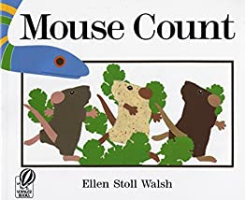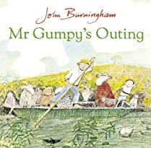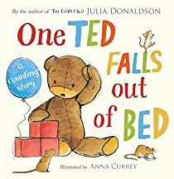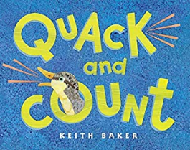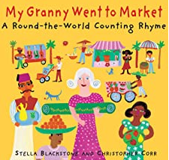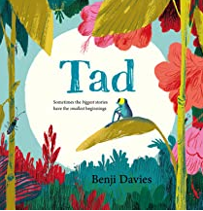  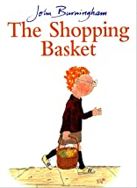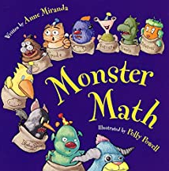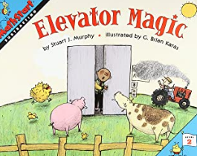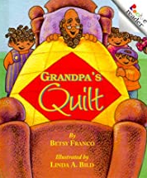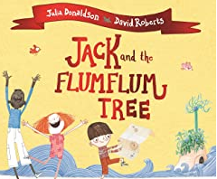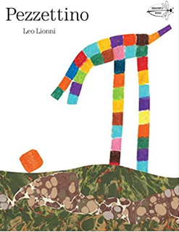
 |  | Consolidation of key skills –  Subitising  Counting  Composition  Sorting and Matching  Comparing and Ordering | Subitising – regular opportunities to instantly recognise small quantities.  Counting – Practice and consolidate counting on and back within 10.  Composition – all quantities are composed of smaller quantities.  Sorting & Matching – Notice similarities and differences.  Comparing & Ordering – Compare and order quantities ad measures.
 |  | Adding More | Use real objects to see that the quantity of a group can be changed by adding more. The first, then, now structure can be used to create maths stories in meaningful contexts.
 |  | Taking Away | Use real objects to see that the quantity of a group can be changed by taking items away. The first, then, now structure can be used to create maths stories in meaningful contexts. Ask the children to count all items at the start, take away the required amount practically and then subitise or recount to see how many are left.
 |  | Shape | Shapes can be combined and separated to make new shapes. Encourage children to explore combining a set of given shapes in different ways.
Find my pattern
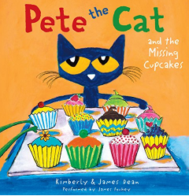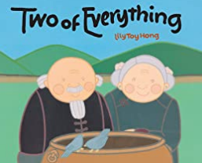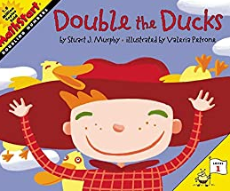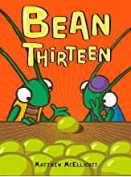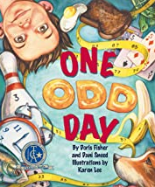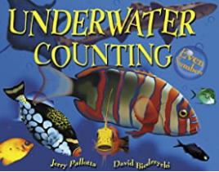

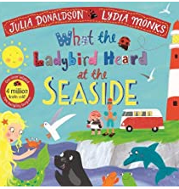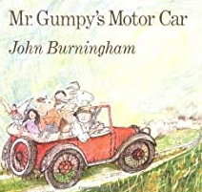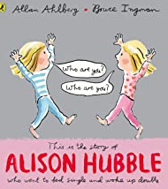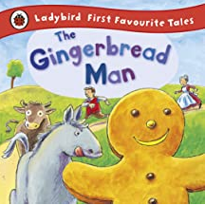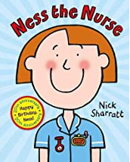

 |  | Doubling | Double means ‘Twice as many’. Build doubles using real life objects & maths equipment. Provide examples of doubles and non-doubles.
 |  | Sharing and Grouping | Equal opportunities to share fairly, recognise and make equal groups. Notice that sometimes there are items left over when they share or group.
 |  | Even and Odd | Some quantities will share equally into 2 groups, and some won’t. They may also notice that some quantities can be grouped into pairs, and some will have one left over.
Understanding the World |  | It is important to recognise learning does not always fit into boxes. Our play-based and child-centred approaches encourage learning to follow where the child’s interest and curiosity leads. Through a balance of guided, planned teaching and pursuing children's own learning within an enabling environment the children will begin to make sense of the physical world and their community.  This document shows the knowledge, skills and understanding what we plan to teach and the planned for experiences we will provide. This is in addition to following children's interests and their curiosity about their world.  Chronology:  Order experiences in relation to themselves and others, including stories. Recount educational visit.  Enquiry:  Comment on images of familiar situations in the past. Describe features of objects, people, places at different times and make comparisons. Talk about what is the same and different.  Respect:  Animals and know how to care for an animal/pets.  Mapping:  Create own maps using grid paper and symbols (x marks the spot treasure maps). |  | Communication: Comment on what they notice about the environment where they live and understand the effect of the changing seasons on the natural world around them. Describe what they see, hear, and feel outside.  Observation: Explore the natural world around them by taking part in weekly forest school inspired ‘Nature School’ sessions and making observations and drawing pictures of animals and plants. Understand the need to respect and care for the natural environment and all living things. |  | LA/EB/SRB/AB | Number Intervention- consolidation of numbers 0-5, order numbers, number bonds to 5. Extend to 10.
Expressive Arts and Design |  | Children will experience and develop a range of creative, artistic skills. The children will have daily, continuous access to a wide range of open ended, ambiguous resources allowing the opportunity to explore, experiment and develop their own creativity. They will have the opportunity to create collaboratively sharing Ideas and resources as well on solo work. Throughout the year the children will have the opportunity to return to and build on their previous learning, refining ideas and developing their ability to represent them. In addition, specific skills and/or experiences will be planned (see below).  Marking Making/Drawing: Skill: produce more detailed work and say what they have included.  Colour: Skill: to be able to choose a particular colour for a purpose.  Painting: Skill: paint through inspiration, feeling, observation or imagination. Evaluate their own work and others, suggest how work can be improved.  Printing: Skill: to be able to create using own ideas and explain the choices.  Textiles/materials: Skill: Sewing using a pre- running stitch with natural resources.  3D Work: Skill focus: be able to select tools and techniques needed to assemble and join materials they are using for a specific reason – woodwork intro.  Cutting Skills: Cutting skill: use scissors for a particular purpose when combining different media and materials.  Artist Study: Henri Matisse  Poetry Basket:  Sliced bread  A Little Shell  Thunderstorm  Under a stone  Charanga Songs:  Reflect, Rewind & Replay  Listen and appraise. Play instruments within the song. Improvisation using voices and instruments. Riff-based composition  Share and perform the learning that has taken place.  Being Imaginative:  Invent, adapt, and recount narratives and stories with peers and their teacher. Creates representations of both imaginary and real-life ideas, events, people, and objects.  Uses combinations of art forms, e.g., moving and singing, making and dramatic play,  drawing and talking, constructing, and mapping |  | Explore, use, and refine a variety of artistic effects to express their ideas and feelings.  Explore and engage in music making and dance, performing solo or in groups. |  | LW/EB/SRB/AB

